A pendulum bob of length, 20.0 cm, has a charge of q = -2.92 x 10⁻⁵ C on it. The pendulum is placed in a constant electric field of strength 9.50 x 10² V/m which points to the left. The pendulum bob has a small mass.

a) Which diagram indicates what will happen in this situation? Explain why.
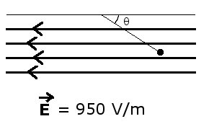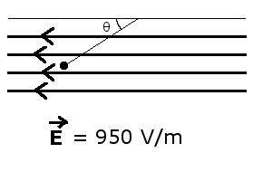
b) Draw a free-body diagram for the charge and label all forces acting on it.

c) If θ = 25.0°, find the mass of the pendulum bob in grams. Assume that the string that attaches it to the ceiling is negligible, and that you are at Earth's surface.

d) Find the potential difference (in volts) between two points in the field that are separated by 25.0 cm in a direction parallel to the field.

e) How many electrons need to be added to the mass to give it a charge of -2.92 x 10⁻⁵ C?

